ANTRIKSH GRAND VIEW COMMERCIAL SPACE PRICE LIST

LOWER GROUND FLOOR
BSP – 13,000 Per Sq.ft
Road PLC – 1000 Per Sq.ft
Corner PLC – 500 Per Sq.ft
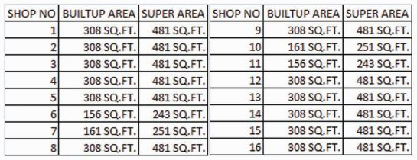
UPPER GROUND FLOOR
BSP – 15,000 Sq.ft
Road PLC – 1000 Per Sq.ft
Corner PLC – 500 Per Sq.ft
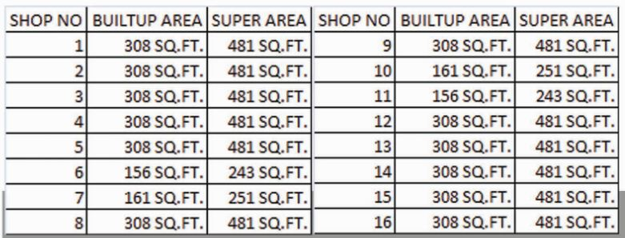

Mode of Payment
At the time of Booking | 10%
Within 60 Days of Booking | 30%
On Completion of Structure | 30%
On offer of Possession | 30%

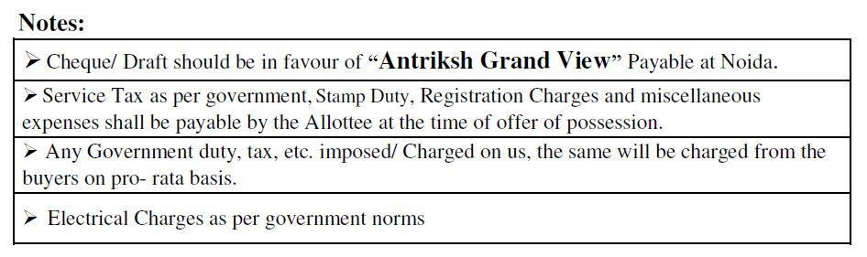
- IFMS 20 rupees Sq.ft Payable at the offer of possession

